
CodeCrawler
Deployment Plan

Team Members:
Nikolay Kujuharov
Martin Mailloux
Mohan Kishore
Kinis Meyer
David Peerenboom
Jebeh Kawah
Omar Ghaffar

Version 1.2

Revision History
Date | Version | Description | Author
11/08/2004 | 0.1 | Draft | Mohan Kishore
11/09/2004 | 0.2 | Merged Martin’s comments | Mohan Kishore
11/21/2004 | 0.3 | Added deployment actions | Mohan Kishore
12/04/2004 | 1.0 | Added deployment diagram | Mohan Kishore
12/05/04 | 1.1 | Added tomcat deployment instr. | Mohan Kishore
3/23/05 | 1.2 | Updated for homework 4 | Kinis Meyer

Table of Contents
1. Introduction 4
1.1 Purpose 4
1.2 Scope 4
1.3 Overview 4
2. Deployment Planning 5
3. Resources 5
3.1 Facilities 5
3.2 Hardware 5
3.3 The Deployment Unit 5
3.3.1 Support Software 5
4. Training 6

Deployment Plan

Introduction

Purpose
This document describes the deployment plan for CodeCrawler project.

Scope
This document is supplemented by the Integration Build Plan document, which describes the plan for building the deployable units. This document describes the process of actually deploying the following deployment units.

Overview
The document is organized in the following manner – Section 2 describes the various deployment activities, the RUP person who is responsible for them and the schedule for the same. Section 3 describes the resources required for the activities.

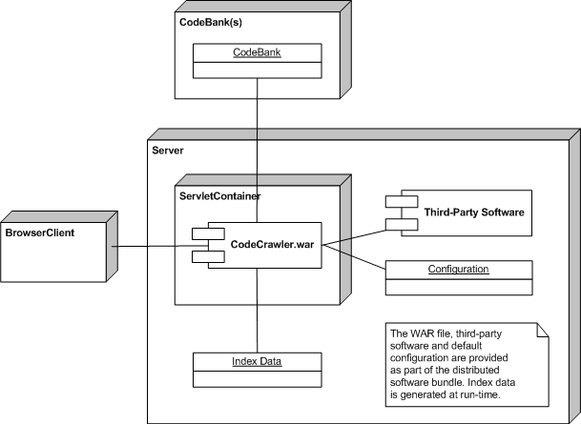

Deployment Planning
Activity | Responsibility | Actions
Deployment Planning | Build Manager and Project Manager | Plan out the release artifacts and schedule.
Support Material Development | Project Manager | Make sure that the documentation is correct and sufficient.
Test Management | Test Manager | Make sure that the unit, integration, and system tests pass.
Producing the Deployment Unit | Build Manager | Run the build scripts and produce the final deliverable.
Testing the Deployment Unit | Test Manager | Sanity check for the final deliverable.
Making the Product Accessible over the Internet | Build and Project Manager | Load it to a publicly accessible URL on Tigris.

Resources

Facilities
The project is hosted on Tigris (web site that promotes open source software development). The project releases will be hosted at http://codecrawler.tigris.org, and will be accessible via a public URL.

Hardware
There are no specific hardware requirements. The server should be able to run a Web Server and Servlet Container, and should have sufficient disk space for managing the index data. The processor and memory requirements will vary depending on the size of the codebanks being managed.

Please refer to the architecture document to see the supported platforms.

The Deployment Unit
The project will be released as a ZIP file. The file will contain the following structure:
<CODECRAWLER_HOME>
- bin
  - Codecrawler.war (the web application archive)
  - Supporting DLL files
- config
  - codecrawler-config.xml
  - Other configuration files
- Docs
To install the application, the user will unzip CodeCrawler and use an install wizard to complete the installation. Please refer to the section below on the necessary support software for installing and using CodeCrawler.

Support Software
The software will be deployed as a web application on a server and the clients will access it via a web browser. The server needs the following installed on it:
- J2DK version 1.4
- a J2EE compliant servlet container – one can get a free and popular container called Tomcat from http://jakarta.apache.org.
- Ant - http://ant.apache.org/

Training
The product is intentionally designed to require minimal training. It will behave very similarly to general search engines, and will provide some additional keywords. The user will be provided will help documents that describe the exact usage scenarios.

